**API Testing using Postman**

**Test case 1: - Verify if user is getting response under “200ms”.**

**Method Used: - Get**

**Endpoint: -** [**https://www.greatcall.com/stores/Api/Products**](https://www.greatcall.com/stores/Api/Products)

**Expected Result: - User should get response under “200ms”.**

**Execution Result:**

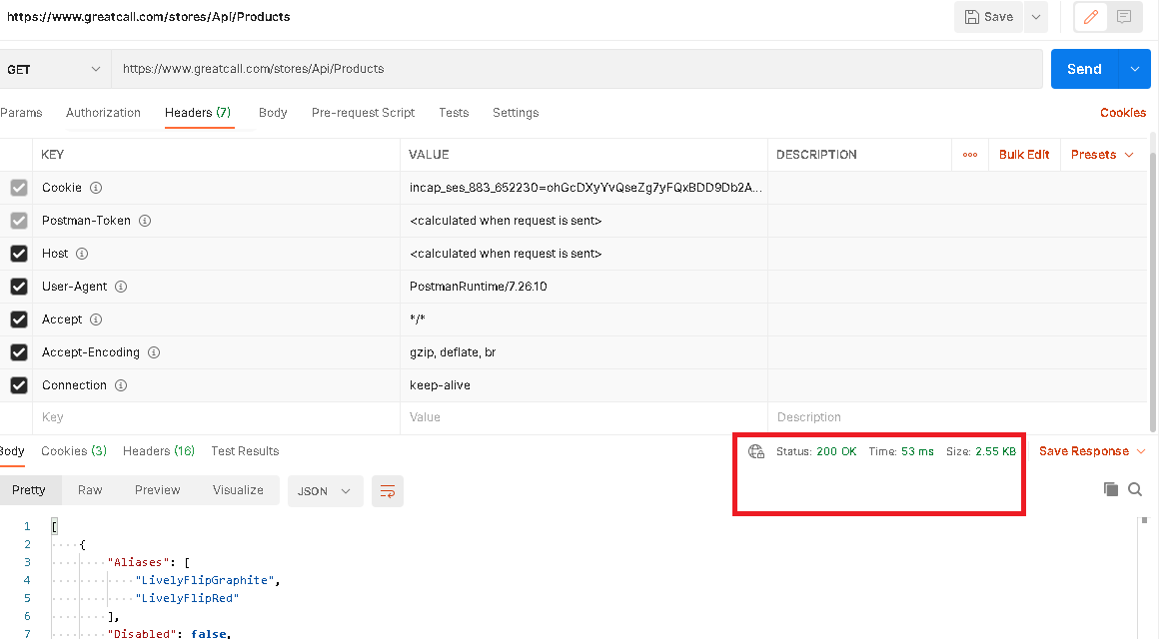

**Test case 2: - Verify if user is getting success status “200 OK”.**

**Endpoint: - https://www.greatcall.com/stores/Api/Products**

**Method Used: - Get**

**Expected Result: - User should get success status “200 OK”.**

**Execution Result:**



**Test case 3: - Verify if user is getting correct error message when “Invalid” URL is submitted.**

**Endpoint: -** [**https://www.greatcall.com/stores/Api/Product**](https://www.greatcall.com/stores/Api/Product)

**Method Used: - Get**

**Expected Result: - User should get correct error message when “Invalid” URL is submitted.**

**Execution Result:**

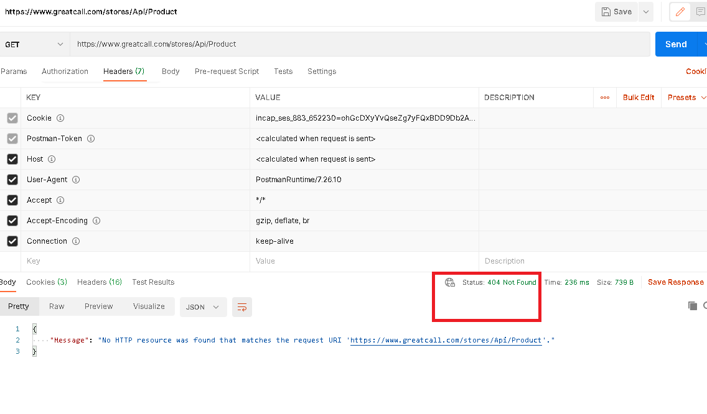

**Test case 4: - Verify if user is getting correct error message when “Invalid” method is used.**

**Endpoint: -** [**https://www.greatcall.com/stores/Api/Product**](https://www.greatcall.com/stores/Api/Product)

**Method Used: - Post**

**Expected Result: - User should get correct error message when “Invalid” method is used.**

**Execution Result:**

